# Installation

Extract the contents of the Deployment folder onto fdc1s-sp23sqlt1. Open PowerShell as administrator, change the directory to the deployment folder path and run the Backup-SQL.ps1.

Extract the contents of the Deployment folder onto fdc1s-sp23wfet1. Open the SharePoint Management console change the directory to the deployment folder path and as administrator and run the DeploymentScript.ps1.

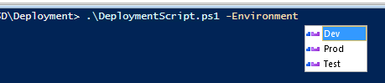

*Select the appropriate Environment when deploying.*

This will install all of the WSPs within the WSPs folder and activate all of the features that were deployed and create a SQL backup of the ASD Content DB.

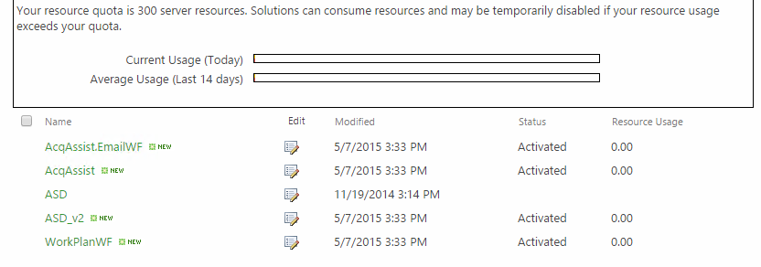

This will also add the new Work Plan site columns to the legacy forms and add a new field to the ASD Base content type and enforce unique values on the Title.

On the Workload page, click on the Page tab and then click Check Out. Next click Edit the page, and insert an Acquisition Assistance web part.

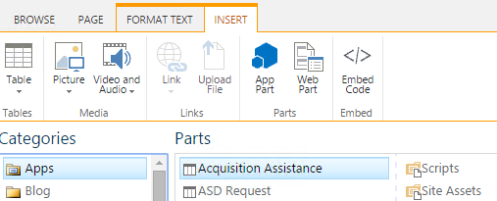

Press the Save button and then edit the page again.

Edit the Acquisition Assistance web part and change the toolbar type to No Toolbar and click apply:

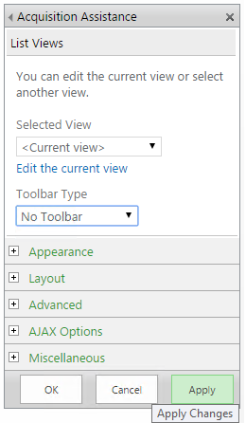

Then click Edit the current view. The settings are as follows:

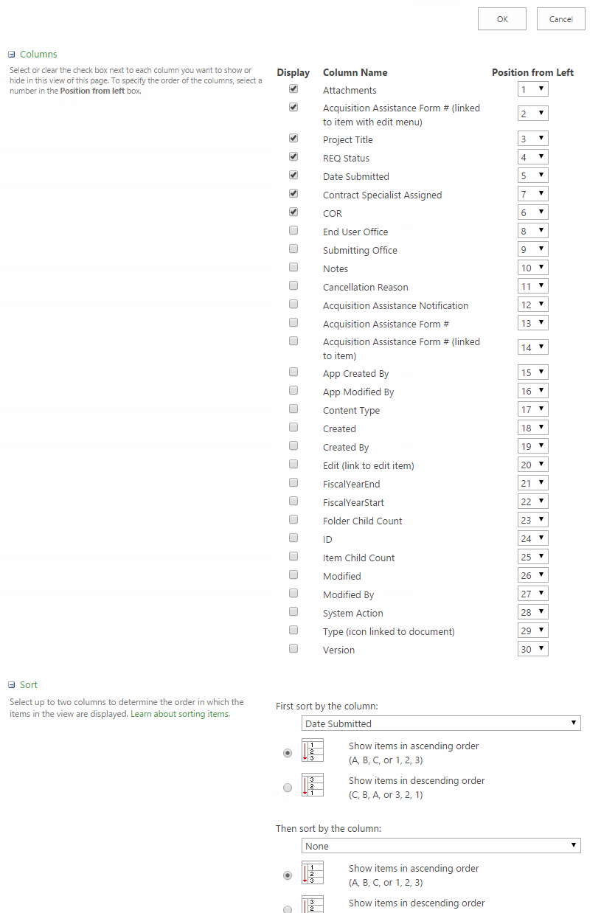

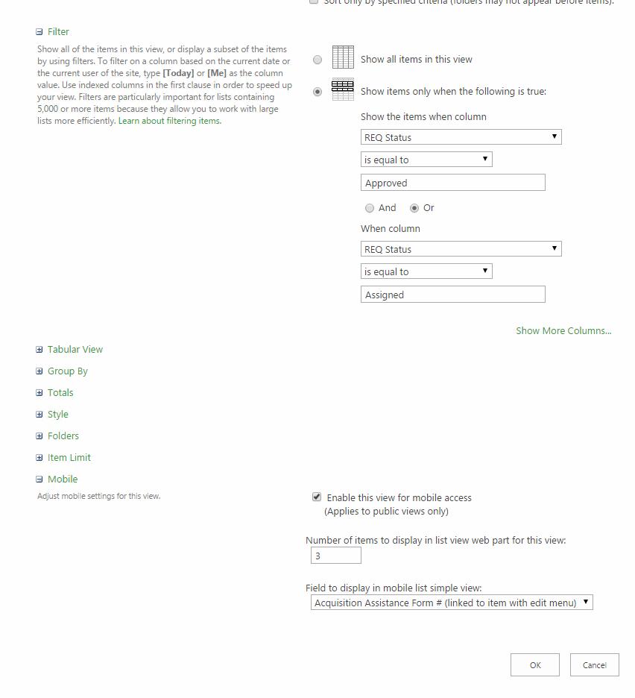

Press OK when finished. Check in the Work Load page:

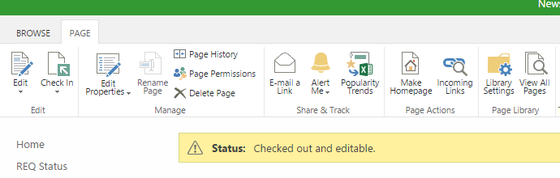

Then open the Site Contents and click on the Site Pages library. Create a new web part page from the Files tab in the ribbon.

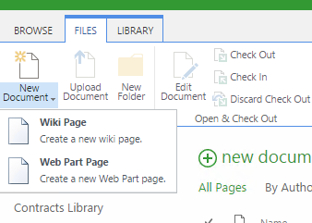

Create the page with these options.

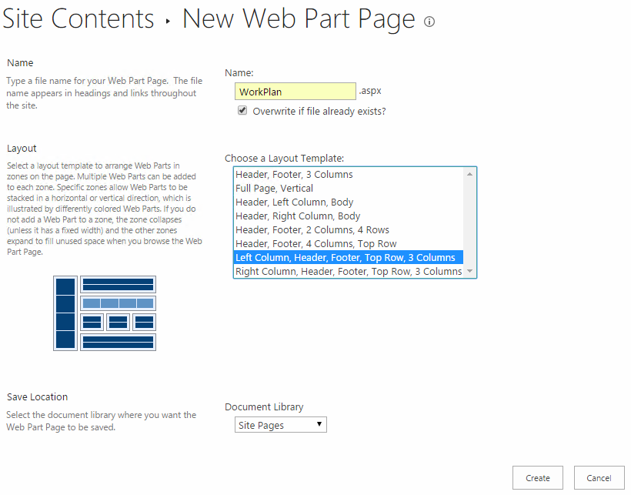

Add a Work Plan List view web part to the WorkPlan page and configure with the settings below.

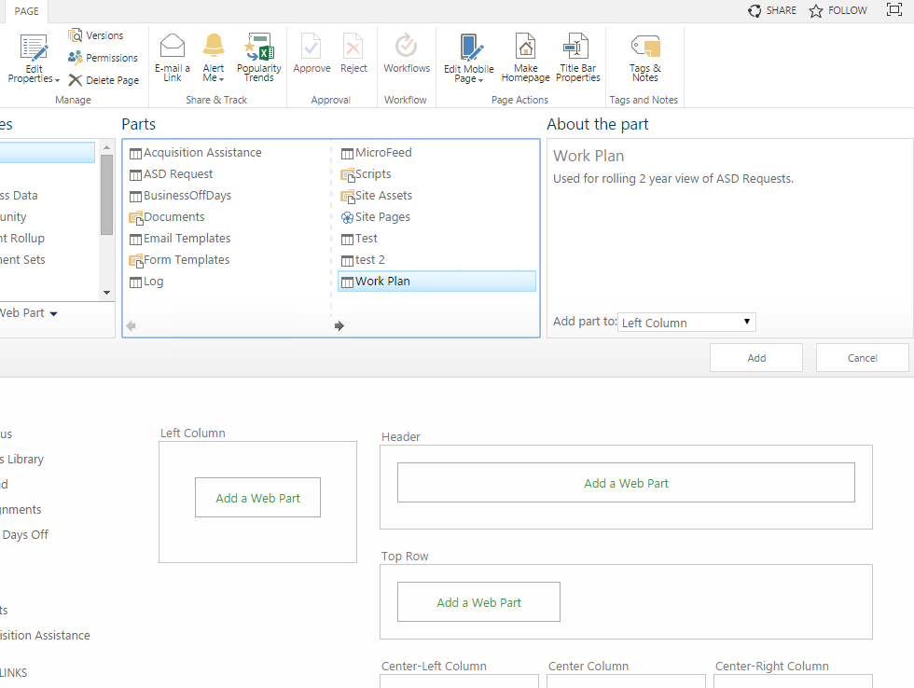

Edit the Work Plan web part and change the toolbar type to No Toolbar and click apply:



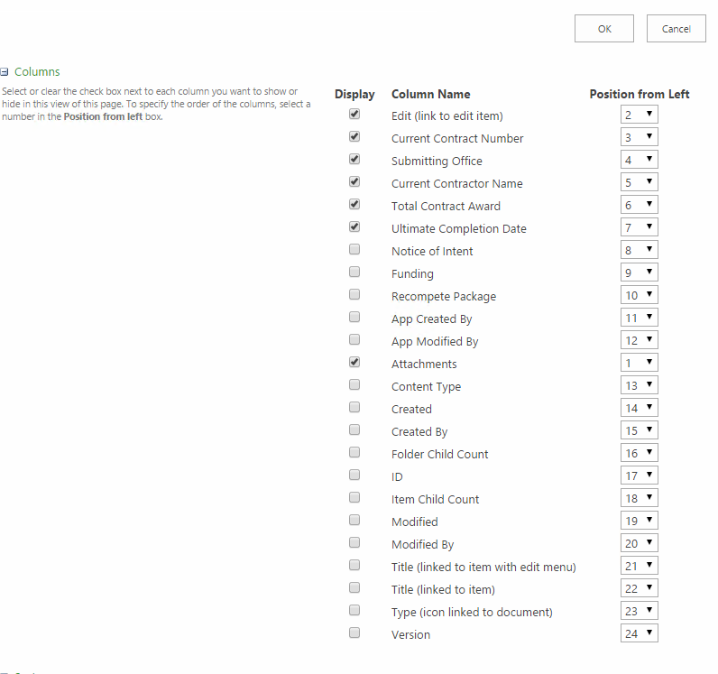

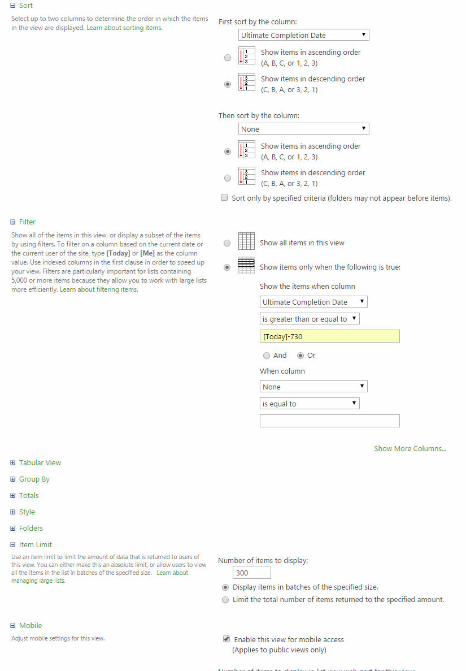

Press OK.

Open the Quick Launch menu from Site Settings and add a New Heading.

Use this URL: /asd/SitePages/WorkPlan.aspx

and name the heading: Work Plan

Change the order of the headings as follows:

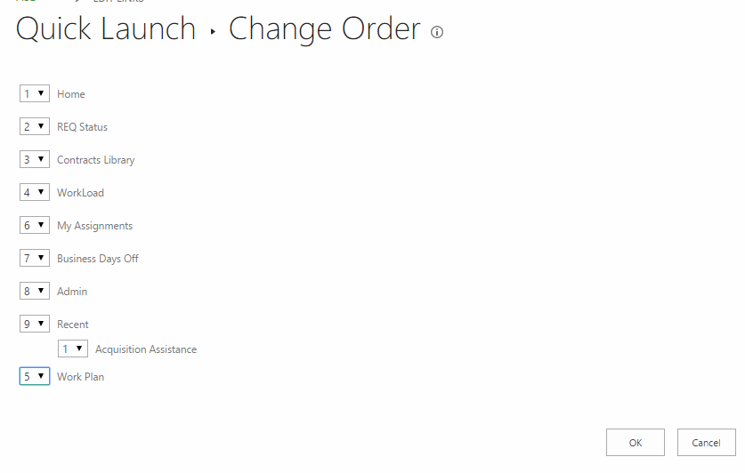

On the home page in the Page tab, press Check Out. Edit the page and add a new link to the page.

URL: /asd/acqassist/newform.aspx?Source=%2Fasd

Name: Request for Acquisition Assistance

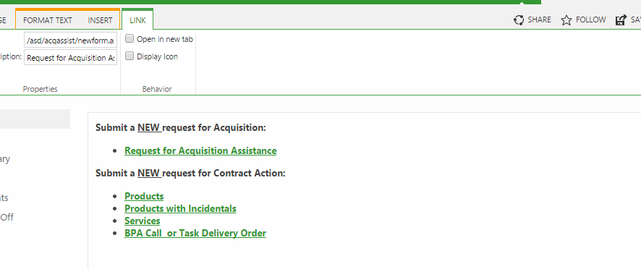

# Rollback

Run the ASD-Restore.ps1 from within the POSH folder. This will restore the backup that was taken prior to deployment.